# [**‘Ghosts’ Finale, ‘SVU’-‘OC’ Crossover, Academy of Country Music Awards on Livestream, Election Day on ‘Station 19’**](https://www.tvinsider.com/1092596/ghosts-finale-svu-oc-crossover-academy-of-country-music-awards-on-livestream-election-day-on-station-19/)

[***Matt Roush***](https://www.tvinsider.com/author/matt-roush/) MAY 11, 7:00 AM

Ownership of the haunted B&B is in question in a busy [***Ghosts***](https://www.tvinsider.com/show/ghosts/) finale. [**Kelli Giddish**](https://www.tvinsider.com/people/kelli-giddish/) returns to the [***Law & Order***](https://www.tvinsider.com/show/law-order/) franchise during a two-week [***Special Victims Unit***](https://www.tvinsider.com/show/law-order-special-victims-unit/) and [***Organized Crime***](https://www.tvinsider.com/show/law-order-organized-crime/) crossover. For the second year, the [**Academy of Country Music Awards**](https://www.tvinsider.com/show/academy-of-country-music-awards/) streams live on [**Prime Video**](https://www.tvinsider.com/network/amazon-prime-video/), with [**Dolly Parton**](https://www.tvinsider.com/people/dolly-parton/) and [**Garth Brooks**](https://www.tvinsider.com/people/garth-brooks/) hosting. Seattle’s new mayor is being elected on [**ABC’s**](https://www.tvinsider.com/network/abc/) [***Station 19***](https://www.tvinsider.com/show/station-19/), but inside the firehouse, several of the lieutenants are jockeying to become the next captain. A curated critical checklist of notable Thursday TV:

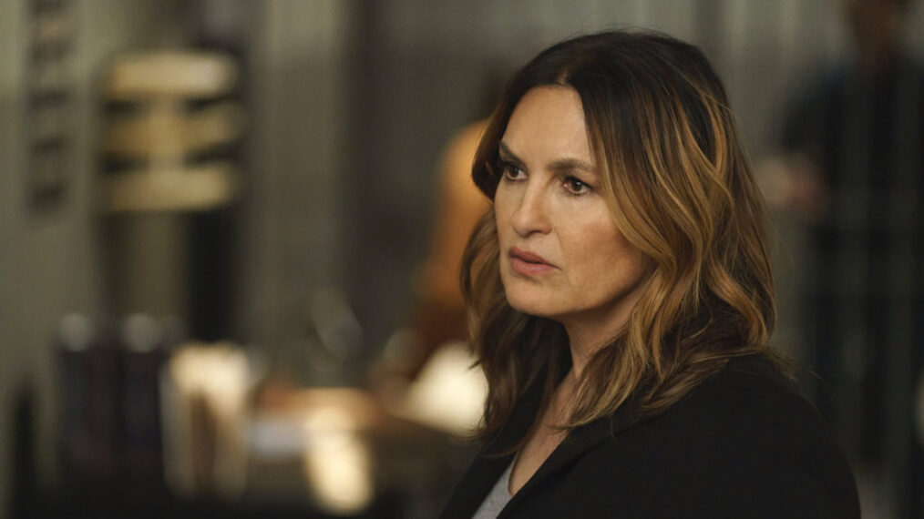

Peter Kramer/NBC

### [**Law & Order: Special Victims Unit**](https://www.tvinsider.com/show/law-order-special-victims-unit/)

 9/8c

The franchise welcomes back Kelli Giddish as former detective, now Professor Amanda Rollins as part of a two-week crossover that brings the SVU and Organized Crime squads together to unravel a global revenge-for-hire conspiracy on the dark web. The story begins when Capt. Olivia Benson ([**Mariska Hargitay**](https://www.tvinsider.com/people/mariska-hargitay)) finds DNA evidence that connects to an Organized Crime case, and Detective Elliot Stabler ([**Christopher Meloni**](https://www.tvinsider.com/people/christopher-meloni)) reaches out to Professor Rollins, who’s expecting again, to work her profiling magic.